Student Name and Number: ___________________________ PRA Section: ___

Student Name and Number: ___________________________

**THE OUTPUT RESISTANCE OF A POWER SUPPLY**

Working with your partner, answer the questions in this exercise and submit them as a single file (including tables, figures, etc.) via Quercus by 11:59 on the 2nd Tuesday following your session (Oct. 4/11). This is not as formal as Lab 1 and Lab 2 which you will do later in the term but make sure that your submission contains the title, both of your names, and the date.

**Objectives:** to review basic electrical measurement techniques; analyze uncertainties of direct and indirect measurements; understand error propagation; apply curve fitting to the set of data points; calculate uncertainty in linear fit.

**I. Introduction**

Any source of electrical energy (generator, battery, thermocouple, etc.) with no load attached to it produces voltage potential across the terminals called an electromotive force (*emf*), or an open-circuit voltage*, $V_{∞}$* .

This number does not completely specify the power supply. In a closed circuit, a current ***I*** will be drawn from the power supply, and the voltage at the terminals, $V$, called *the terminal voltage*, will typically fall below $V_{∞}$. A plot of what the terminal voltage $V$ vs. current $I$ may look like is shown in Fig. 1.

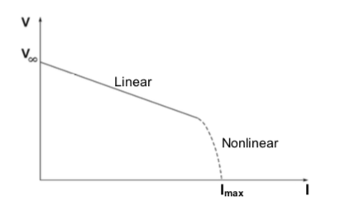

FIG.1: Terminal voltage vs. current

Many power sources will exhibit a linear variation of *V* for small current values, followed by a nonlinear behaviour at higher currents. The linear part of the curve can be described by

$V=V_{∞}-RI,$ (1)

where $R$ is the *output resistance of the power source*. In this linear regime, according to Thevenin’s theorem, the power source is completely represented by this equivalent circuit as in Fig. 2.

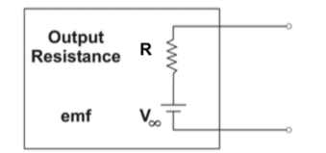

Fig. 2. Equivalent circuit of an electric power source.

The output resistance ($R$) can be determined by attaching different external resistances of the load ($R_{l}$)to the power source, and measuring the current and voltage with a multimeter. Figure 3 shows two possible ways of doing this. Both would be equivalent **if** the multimeter were ideal. However, in this exercise we will measure with real, not ideal, multimeters.

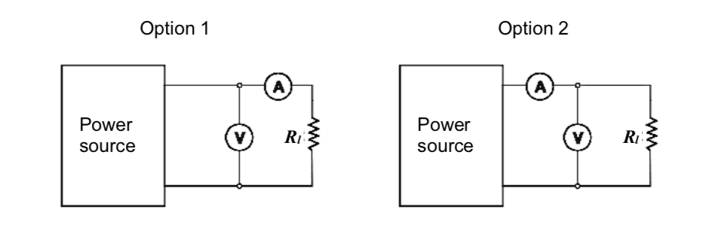

Fig. 3. Possible circuits for determining the output resistance of a power source.

|  |
| --- |
| **Question 1:**  Without connecting circuits and making measurements, how would you expect the readings of the voltmeter and the ammeter to differ between Option 1 and in Option 2? Explain. |

|  |
| --- |
| **Question 2:**  To calculate the resistance of the power source, you will need to know the internal resistance of the voltmeter and the ammeter. How can you find these values by making measurements of current and voltage with the Option 1 and Option 2 circuits? Derive the general formulae for the internal resistance of the voltmeter and the ammeter based on the results of these measurements and the known resistance of the load. |

**To find resistance of ammeter: Go to option 1, R_a&r = (V / I), R_a = R_a&r – R_r**

**To find resistance of voltmeter: Go to option 2, I_r = V / R_r, I_V = I – I_r, V_v = (I_a – I_v )* R_r**

**Therefore R_v = R_r * V / (I * R_r – V)**

**II. The Experiment**

Measure the resistance of up to 7 resistors with the multimeter set to ohmmeter. Use the data to complete the table below and indicate the (reading) uncertainty for each measurement.

Table 1

|  |  |  |  |  |  |  |  |  |  |  |  |  |  |
| --- | --- | --- | --- | --- | --- | --- | --- | --- | --- | --- | --- | --- | --- |
| $$R_{l1}$$ $$Ω$$ | $${ΔR}_{l1}$$ $$Ω$$ | $$R_{l2}$$ $$Ω$$ | $${ΔR}_{l2}$$ $$Ω$$ | $$R_{l3}$$ K $Ω$ | $${ΔR}_{l3}$$ $$Ω$$ | $$R_{l4}$$ K $Ω$ | $${ΔR}_{l4}$$ $$Ω$$ | $$R_{l5}$$ K $Ω$ | $${ΔR}_{l5}$$ $$Ω$$ | $$R_{l6}$$ K $Ω$ | $${ΔR}_{l6}$$ $$Ω$$ | $$R_{l7}$$ $$Ω$$ | $${ΔR}_{l7}$$ $$Ω$$ |
| 100.69 | .005 | 219.63 | .005 | .4656 (kohms) | .05 | 2.6934 (kohms) | .05 | 26.978 (kohms) | .5 | 101.40 (kohms) | 5 |  |  |

|  |
| --- |
| **Question 3:**  Choose at least 4 of these resistors to construct circuits for this experiment. Briefly justify your choice. |
| **219.63 ohms, 465.6 ohms, 2.6934 kohms, and 26.978 kohms. Picking smaller resistances allows for a more accurate calculation of the ammeter resistance, because the resistance isn’t >> the applied current (0.200 A).** |

**Circuit Option 1:**

* Assemble circuit Option 1 (Fig. 3). Sketch or photograph it and include this sketch/photograph in your report. List the elements of the circuit in a caption.
* If you are working with a DC power supply, set it to about 6.5V. (A 0.063)
* Measure the voltage $V$ and current $I$ for circuits with your four chosen resistors. You can use more than 4 resistors if you like. Use this information to calculate the internal resistance of the ammeter. Organize all of the data in Table 2.

Table 2. For Circuit Option 1

**To find resistance of ammeter: Go to option 1, R_a&r = (V / I), R_a = R_a&r – R_r**

|  |  |  |  |  |  |  |  |  |
| --- | --- | --- | --- | --- | --- | --- | --- | --- |
|  | **Resistance $$R_{li},Ω$$** | **Uncertainty $${ΔR}_{li},Ω$$** | **Voltage $V,$ V** | **Uncertainty $ΔV,$**  **V** | **Current $I$**  **, mA** | **Uncertainty $ΔI$**  **, mA** | **Resistance of ammeter $$R_{A},Ω$$** | **Uncertainty $${ΔR}_{A},Ω$$** |
| **1** | 219.63 | .005 | 6.500 | .0005 | 29.286 | .0005 | 2.32 |  |
| **2** | 456.6 | .05 | 6.500 | .0005 | 13.885 | .0005 | 11.53 |  |
|  | 676.23 | .55 | 6.500 | .0005 | 9.450 | .0005 | 11.60 |  |
| **3** | 2 693.4 | .05 | 6.500 | .0005 | 2.410 | .0005 | 3.69 |  |
| **4** | 100.69 | .005 | 6.500 | .0005 | 63.14 | .005 | 2.26 |  |
| **5** | 320.32 | .001 | 6.500 | .0005 | 20.150 | .0005 | 2.26 |  |
|  |  |  |  |  |  |  |  |  |
|  |  |  |  |  |  | **Average:** |  |  |

* Plot $V$ vs $I$ and apply a linear fit to determine the slope $m_{1}$ and its uncertainty. Check two goodness of fit criteria.

**Circuit Option 2:**

* Assemble circuit Option 2 (Fig. 3).
* Measure the voltage $V$ and current $I$ for circuits with your four (or more) chosen resistors. Use this information to calculate the internal resistance of the voltmeter. Organize all of the data in Table 2.

Table 3. For Circuit Option 2

**Therefore R_v = R_r * V/ (I * R_r – V)**

|  |  |  |  |  |  |  |  |  |
| --- | --- | --- | --- | --- | --- | --- | --- | --- |
|  | **Resistance $$R_{li},Ω$$** | **Uncertainty $${ΔR}_{li},Ω$$** | **Voltage $V,$ V** | **Uncertainty $ΔV,$**  **V** | **Current $I$**  **, mA** | **Uncertainty $ΔI$**  **, mA** | **Resistance of voltmeter (milli) $$R_{V},Ω$$** | **Uncertainty $${ΔR}_{V},Ω$$** |
| **1** | 100.69 | .005 | 6.499 | .0005 | 63.14 | .005 | -4627.51 |  |
| **2** | 219.63 | .005 | 6.499 | .0005 | 29.291 | .0005 |  |  |
| **3** | 320.32 | .005 | 6.500 |  | 20.148 |  |  |  |
| **4** | 456.6 | .005 | 6.500 |  | 13.885 |  |  |  |
| **5** | 676.23 | .55 | 6.500 |  | 9.450 |  |  |  |
| **6** | 2693.4 | .05 | 6.500 |  | 2.410 |  |  |  |
|  |  |  |  |  |  | **Average:** |  |  |

* Plot $V$ vs $I$ and apply a linear fit to determine the slope $m_{2}$ and its uncertainty. Check two goodness of fit criteria.

**III. Analysis**

* Derive a relationship among $m_{1}$, $R_{V}$ and $R_{1}$ to find the output resistance with its uncertainty. Show the steps of your error propagation calculation for the uncertainty of $R_{1}$***.***
* Derive a relationship among $m_{2}$, $R_{A}$ and $R_{2}$ to find the output resistance with its uncertainty. Show the steps of your error propagation calculation for the uncertainty of $R_{2}$***.***
* Show the output resistance of the battery (or DC power supply) as: $R_{1}$**=** ( **___ ± ___** ) Ω and $R_{2}$**=** ( **___ ± ___** ) Ω.
* Write a brief conclusion on the difference between the two results.